Practical 8
Title / Aim :- To access and validate form fields using events:
design a gym admission form with live input checks
Software/Tools Required: VS Code , Web Browser
Experiment program code:
<html>
<head>
<title>Gym Admission Form</title>
<style>
body {
font-family: Arial, sans-serif;
background-color: #f2f2f2;
text-align: center;
padding: 40px;
}
h2 {
color: #1a5cff;
}
form {
max-width: 320px;
margin: 20px auto;
background-color: white;
padding: 20px;
border-radius: 6px;
border: 1px solid #ccc;
text-align: left;
}
label {
display: block;
margin-top: 12px;
font-size: 14px;
color: #333;
}
input, select {
width: 100%;
padding: 8px;
margin-top: 4px;
border: 1px solid #ccc;
border-radius: 4px;
box-sizing: border-box;
font-size: 14px;
}
.error {
color: red;
font-size: 12px;
margin-top: 3px;
display: block;
}
button {
margin-top: 18px;
width: 100%;
padding: 9px;
background-color: #1a5cff;
color: white;
border: none;
border-radius: 4px;
font-size: 15px;
cursor: pointer;
}
button:hover {
background-color: #0d3fb0;
}
#successMsg {
color: green;
margin-top: 15px;
font-size: 15px;
}
</style>
</head>
<body>
<h2>Gym Admission Form</h2>
<label>Sanvi Wadhankar 24070521191</label>
<form id="gymForm">
<label for="fullName">Full Name</label>
<input type="text" id="fullName">
<span class="error" id="nameError"></span>
<label for="email">Email</label>
<input type="text" id="email">
<span class="error" id="emailError"></span>
<label for="phone">Phone Number</label>
<input type="text" id="phone" maxlength="10">
<span class="error" id="phoneError"></span>
<label for="age">Age</label>
<input type="number" id="age">
<span class="error" id="ageError"></span>
<label for="plan">Membership Plan</label>
<select id="plan">
<option value="">-- Select a Plan --</option>
<option value="Basic">Basic</option>
<option value="Standard">Standard</option>
<option value="Premium">Premium</option>
</select>
<span class="error" id="planError"></span>
<button type="button" onclick="submitForm()">Submit</button>
<p id="successMsg"></p>
</form>
<script>
// Grabbing all fields using DOM
var nameField = document.getElementById("fullName");
var emailField = document.getElementById("email");
var phoneField = document.getElementById("phone");
var ageField = document.getElementById("age");
var planField = document.getElementById("plan");
// ---------- VALIDATION FUNCTIONS ----------
function validateName() {
if (nameField.value.trim() === "") {
document.getElementById("nameError").innerHTML = "Please enter your full name";
return false;
} else {
document.getElementById("nameError").innerHTML = "";
return true;
}
}

function validateEmail() {
var email = emailField.value;
// must contain @, no spaces, and end with .com
var emailPattern = /^[^\s@]+@[^\s@]+\.com$/;
if (!emailPattern.test(email)) {
document.getElementById("emailError").innerHTML = "Enter a valid email";
return false;
} else {
document.getElementById("emailError").innerHTML = "";
return true;
}
}
function validatePhone() {
var phone = phoneField.value;
var phonePattern = /^[0-9]{10}$/;
if (!phonePattern.test(phone)) {
document.getElementById("phoneError").innerHTML = "Enter valid 10 digit number";
return false;
} else {
document.getElementById("phoneError").innerHTML = "";
return true;
}
}
function validateAge() {
var age = Number(ageField.value);
if (ageField.value === "" || age < 16 || age > 60) {
document.getElementById("ageError").innerHTML = "Age must be between 16 and 60";
return false;
} else {
document.getElementById("ageError").innerHTML = "";
return true;
}
}
function validatePlan() {
if (planField.value === "") {
document.getElementById("planError").innerHTML = "Please select a membership plan";
return false;
} else {
document.getElementById("planError").innerHTML = "";
return true;
}
}
// ---------- LIVE VALIDATION USING EVENTS ----------
nameField.addEventListener("input", validateName);
emailField.addEventListener("input", validateEmail);
phoneField.addEventListener("input", validatePhone);
ageField.addEventListener("input", validateAge);
planField.addEventListener("change", validatePlan);
// ---------- FORM SUBMISSION ----------
function submitForm() {
var isNameValid = validateName();
var isEmailValid = validateEmail();
var isPhoneValid = validatePhone();
var isAgeValid = validateAge();
var isPlanValid = validatePlan();

if (isNameValid && isEmailValid && isPhoneValid && isAgeValid && isPlanValid) {
document.getElementById("successMsg").innerHTML =
"Form submitted successfully! Welcome, " + nameField.value + ".";
} else {
document.getElementById("successMsg").innerHTML = "";
alert("Please correct the highlighted errors before submitting.");
}
}
</script>
</body>
</html>
Output:-
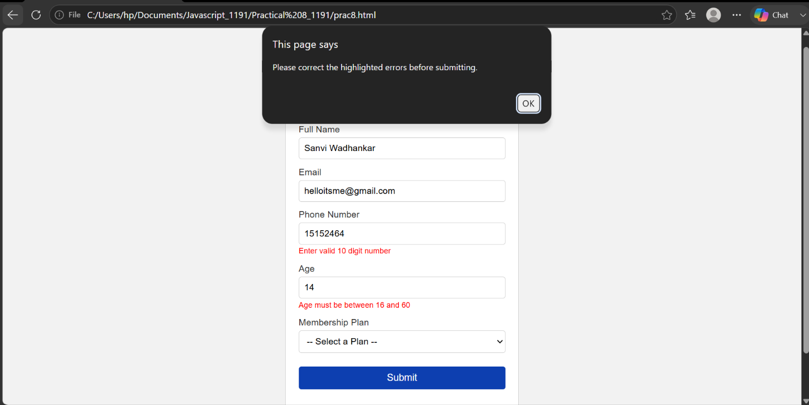
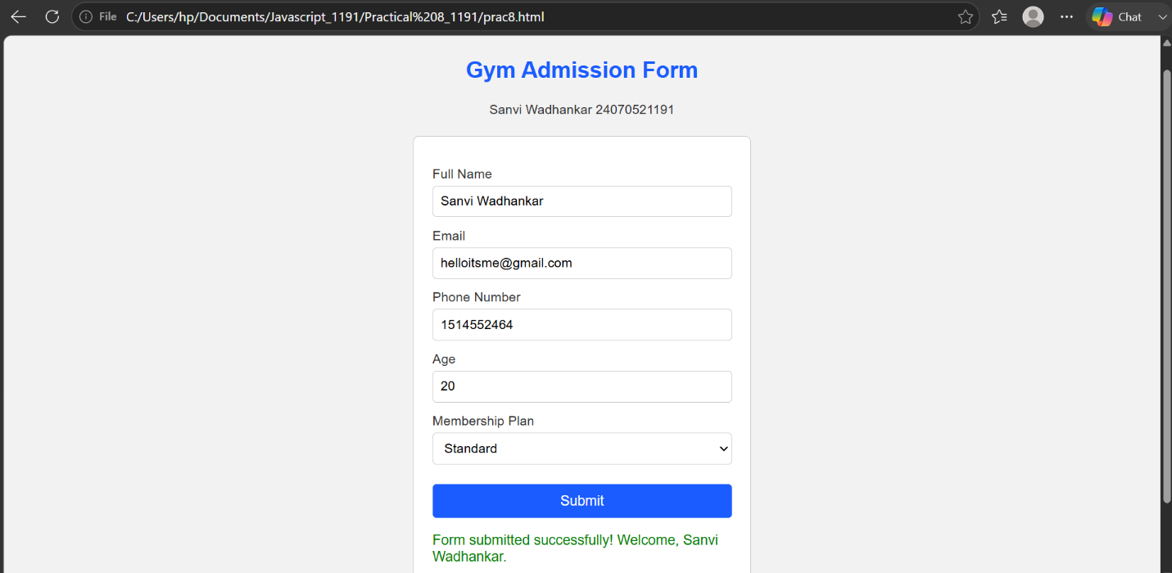
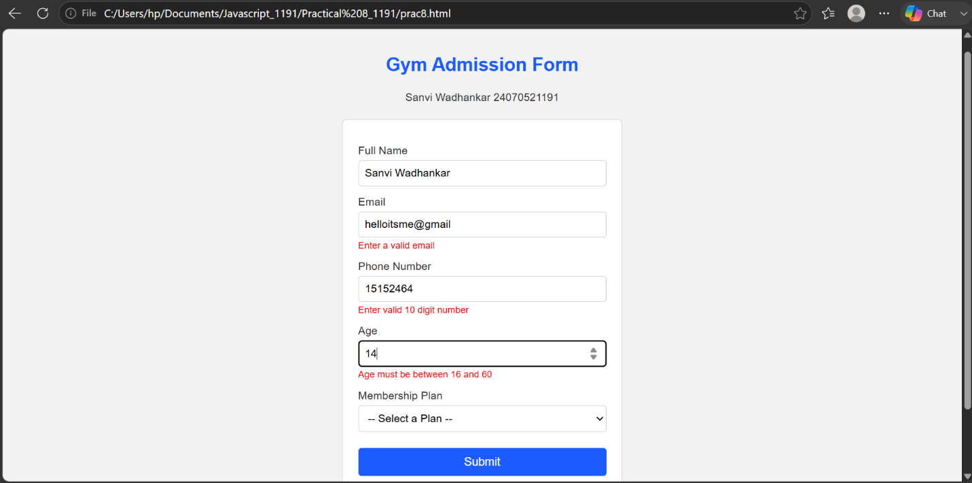

Case Study 8
Aim:- online job application form
- a company wants to create an online job application form for applicants.
- the form should check the entered info immediately and prevent submission when the details are invalid.
- do not let them enter invalid information and submit the form if trying to submit give error or invalid data messages

Software/Tools Required: VS Code , Web Browser
Case Study Code:-

<html>
<head>
<title>Job Application Form</title>
<style>
* {
box-sizing: border-box;
}
body {
font-family: 'Segoe UI', Arial, sans-serif;
background: linear-gradient(135deg, #eef3ff, #dbe7ff);
padding: 40px 15px;
margin: 0;
}
.container {
max-width: 700px;
margin: 0 auto;
}
.header {
text-align: center;
margin-bottom: 25px;
}
.header h2 {
color: #1a5cff;
margin-bottom: 5px;
}
.header p {
color: #666;
font-size: 14px;
}
form {
background-color: white;
padding: 30px;
border-radius: 12px;
box-shadow: 0 8px 25px rgba(0,0,0,0.08);
}
.section {
margin-bottom: 25px;
padding-bottom: 15px;
border-bottom: 1px solid #eee;
}
.section:last-of-type {
border-bottom: none;
}
.section h3 {
color: #1a5cff;
font-size: 17px;
margin-bottom: 15px;
display: flex;
align-items: center;
gap: 8px;
}
.grid {
display: grid;
grid-template-columns: 1fr 1fr;
gap: 15px;
}
.full-width {
grid-column: 1 / -1;
}
.field {
display: flex;
flex-direction: column;
}
label {
font-size: 13px;
color: #444;
margin-bottom: 5px;
font-weight: 600;
}
input, select {
padding: 9px 10px;
border: 1px solid #ccc;
border-radius: 6px;
font-size: 14px;
outline: none;
transition: border-color 0.2s;
}
input:focus, select:focus {
border-color: #1a5cff;
}
.error {
color: #e63946;
font-size: 12px;
margin-top: 4px;
min-height: 14px;
}
button {
margin-top: 10px;
width: 100%;
padding: 12px;
background-color: #1a5cff;
color: white;
border: none;
border-radius: 8px;
font-size: 16px;
font-weight: 600;
cursor: pointer;
transition: background-color 0.2s;
}
button:hover {
background-color: #0d3fb0;
}
#successMsg {
text-align: center;
color: #2a9d3f;
margin-top: 15px;
font-size: 15px;
font-weight: 600;
}
@media (max-width: 600px) {
.grid {
grid-template-columns: 1fr;
}
}
</style>
</head>
<body>

<div class="container">

<div class="header">
<h2>Online Job Application Form</h2>
<p>Sanvi Wadhankar 24070521191</p>
<p>Fill in your details below. All fields are checked as you type.</p>
</div>

<form id="jobForm">

<div class="section">
<h3>Personal Info</h3>
<div class="grid">

<div class="field">
<label for="name">Name</label>
<input type="text" id="name">
<span class="error" id="nameError"></span>
</div>

<div class="field">
<label for="email">Email</label>
<input type="text" id="email">
<span class="error" id="emailError"></span>
</div>

<div class="field">
<label for="dob">Birth Date</label>
<input type="date" id="dob">
<span class="error" id="dobError"></span>
</div>

<div class="field">
<label for="gender">Gender</label>
<select id="gender">
<option value="">-- Select --</option>
<option value="Male">Male</option>
<option value="Female">Female</option>
<option value="Other">Other</option>
</select>
<span class="error" id="genderError"></span>
</div>

<div class="field">
<label for="phone">Phone Number</label>
<input type="text" id="phone" maxlength="10">
<span class="error" id="phoneError"></span>
</div>

<div class="field">
<label for="pincode">Pin Code</label>
<input type="text" id="pincode" maxlength="6">
<span class="error" id="pincodeError"></span>
</div>

<div class="field full-width">
<label for="address">Address</label>
<input type="text" id="address">
<span class="error" id="addressError"></span>
</div>

<div class="field">
<label for="city">City</label>
<input type="text" id="city">
<span class="error" id="cityError"></span>
</div>

<div class="field">
<label for="state">State</label>
<input type="text" id="state">
<span class="error" id="stateError"></span>
</div>

</div>
</div>

<div class="section">
<h3>Educational Qualification</h3>
<div class="grid">

<div class="field">
<label for="qualification">Highest Qualification</label>
<input type="text" id="qualification">
<span class="error" id="qualificationError"></span>
</div>

<div class="field">
<label for="institute">University / Institute</label>
<input type="text" id="institute">
<span class="error" id="instituteError"></span>
</div>

<div class="field">
<label for="passingYear">Passing Year</label>
<input type="text" id="passingYear" maxlength="4">
<span class="error" id="passingYearError"></span>
</div>

<div class="field">
<label for="cgpa">CGPA (out of 10)</label>
<input type="text" id="cgpa">
<span class="error" id="cgpaError"></span>
</div>

</div>
</div>

<div class="section">
<h3>Professional Info</h3>
<div class="grid">

<div class="field">
<label for="jobPosition">Applying For / Job Position</label>
<input type="text" id="jobPosition">
<span class="error" id="jobPositionError"></span>
</div>

<div class="field">
<label for="experience">Total Work Experience (Years)</label>
<input type="text" id="experience">
<span class="error" id="experienceError"></span>
</div>

<div class="field">
<label for="organization">Current / Previous Organization</label>
<input type="text" id="organization">
<span class="error" id="organizationError"></span>
</div>

<div class="field">
<label for="designation">Current Designation</label>
<input type="text" id="designation">
<span class="error" id="designationError"></span>
</div>

<div class="field full-width">
<label for="salary">Expected Salary</label>
<input type="text" id="salary">
<span class="error" id="salaryError"></span>
</div>

</div>
</div>

<div class="section">
<h3>Technical Skills</h3>
<div class="grid">

<div class="field">
<label for="languages">Programming Languages</label>
<input type="text" id="languages">
<span class="error" id="languagesError"></span>
</div>

<div class="field">
<label for="skills">Technical Skills</label>
<input type="text" id="skills">
<span class="error" id="skillsError"></span>
</div>

<div class="field full-width">
<label for="certifications">Certifications</label>
<input type="text" id="certifications">
</div>

</div>
</div>

<button type="button" onclick="submitForm()">Submit Application</button>

<p id="successMsg"></p>

</form>

</div>

<script>
// ---------- FIELD REFERENCES ----------
var nameField = document.getElementById("name");
var emailField = document.getElementById("email");
var dobField = document.getElementById("dob");
var genderField = document.getElementById("gender");
var addressField = document.getElementById("address");
var phoneField = document.getElementById("phone");
var pincodeField = document.getElementById("pincode");
var cityField = document.getElementById("city");
var stateField = document.getElementById("state");

var qualificationField = document.getElementById("qualification");
var instituteField = document.getElementById("institute");
var passingYearField = document.getElementById("passingYear");
var cgpaField = document.getElementById("cgpa");

var jobPositionField = document.getElementById("jobPosition");
var experienceField = document.getElementById("experience");
var organizationField = document.getElementById("organization");
var designationField = document.getElementById("designation");
var salaryField = document.getElementById("salary");

var languagesField = document.getElementById("languages");
var skillsField = document.getElementById("skills");

// ---------- VALIDATION FUNCTIONS ----------

function validateName() {
if (nameField.value.trim() === "") {
document.getElementById("nameError").innerHTML = "Name is required";
return false;
}
document.getElementById("nameError").innerHTML = "";
return true;
}

function validateEmail() {
var pattern = /^[^\s@]+@[^\s@]+\.com$/;
if (!pattern.test(emailField.value)) {
document.getElementById("emailError").innerHTML = "Enter a valid email";
return false;
}
document.getElementById("emailError").innerHTML = "";
return true;
}

function validateDob() {
if (dobField.value === "") {
document.getElementById("dobError").innerHTML = "Birth date is required";
return false;
}
var dob = new Date(dobField.value);
var today = new Date();
var age = today.getFullYear() - dob.getFullYear();
var monthDiff = today.getMonth() - dob.getMonth();
if (monthDiff < 0 || (monthDiff === 0 && today.getDate() < dob.getDate())) {
age--;
}
if (age < 18) {
document.getElementById("dobError").innerHTML = "Applicant must be at least 18 years old";
return false;
}
document.getElementById("dobError").innerHTML = "";
return true;
}

function validateGender() {
if (genderField.value === "") {
document.getElementById("genderError").innerHTML = "Please select gender";
return false;
}
document.getElementById("genderError").innerHTML = "";
return true;
}

function validateAddress() {
if (addressField.value.trim() === "") {
document.getElementById("addressError").innerHTML = "Address is required";
return false;
}
document.getElementById("addressError").innerHTML = "";
return true;
}

function validatePhone() {
var pattern = /^[0-9]{10}$/;
if (!pattern.test(phoneField.value)) {
document.getElementById("phoneError").innerHTML = "Enter valid 10 digit number";
return false;
}
document.getElementById("phoneError").innerHTML = "";
return true;
}

function validatePincode() {
var pattern = /^[0-9]{6}$/;
if (!pattern.test(pincodeField.value)) {
document.getElementById("pincodeError").innerHTML = "Enter valid 6 digit pin code";
return false;
}
document.getElementById("pincodeError").innerHTML = "";
return true;
}

function validateCity() {
if (cityField.value.trim() === "") {
document.getElementById("cityError").innerHTML = "City is required";
return false;
}
document.getElementById("cityError").innerHTML = "";
return true;
}

function validateState() {
if (stateField.value.trim() === "") {
document.getElementById("stateError").innerHTML = "State is required";
return false;
}
document.getElementById("stateError").innerHTML = "";
return true;
}

function validateQualification() {
if (qualificationField.value.trim() === "") {
document.getElementById("qualificationError").innerHTML = "Qualification is required";
return false;
}
document.getElementById("qualificationError").innerHTML = "";
return true;
}

function validateInstitute() {
if (instituteField.value.trim() === "") {
document.getElementById("instituteError").innerHTML = "Institute name is required";
return false;
}
document.getElementById("instituteError").innerHTML = "";
return true;
}

function validatePassingYear() {
var year = Number(passingYearField.value);
var currentYear = new Date().getFullYear();
// Allows past years (already graduated) and up to 5 years ahead (expected graduation)
if (!/^[0-9]{4}$/.test(passingYearField.value) || year < 1950 || year > currentYear + 5) {
document.getElementById("passingYearError").innerHTML = "Enter a valid passing year";
return false;
}
document.getElementById("passingYearError").innerHTML = "";
return true;
}

function validateCgpa() {
var value = Number(cgpaField.value);
if (cgpaField.value.trim() === "" || isNaN(value) || value < 0 || value > 10) {
document.getElementById("cgpaError").innerHTML = "Enter valid CGPA (0-10)";
return false;
}
document.getElementById("cgpaError").innerHTML = "";
return true;
}

function validateJobPosition() {
if (jobPositionField.value.trim() === "") {
document.getElementById("jobPositionError").innerHTML = "Job position is required";
return false;
}
document.getElementById("jobPositionError").innerHTML = "";
return true;
}

function validateExperience() {
var value = Number(experienceField.value);
if (experienceField.value.trim() === "" || isNaN(value) || value < 0 || value > 50) {
document.getElementById("experienceError").innerHTML = "Enter valid years of experience";
return false;
}
document.getElementById("experienceError").innerHTML = "";
return true;
}

function validateOrganization() {
document.getElementById("organizationError").innerHTML = "";
return true;
}

function validateDesignation() {
document.getElementById("designationError").innerHTML = "";
return true;
}

function validateSalary() {
var value = Number(salaryField.value);
if (salaryField.value.trim() === "" || isNaN(value) || value <= 0) {
document.getElementById("salaryError").innerHTML = "Enter valid expected salary";
return false;
}
document.getElementById("salaryError").innerHTML = "";
return true;
}

function validateLanguages() {
if (languagesField.value.trim() === "") {
document.getElementById("languagesError").innerHTML = "Enter at least one programming language";
return false;
}
document.getElementById("languagesError").innerHTML = "";
return true;
}

function validateSkills() {
if (skillsField.value.trim() === "") {
document.getElementById("skillsError").innerHTML = "Enter at least one technical skill";
return false;
}
document.getElementById("skillsError").innerHTML = "";
return true;
}

// ---------- LIVE VALIDATION USING EVENTS ----------

nameField.addEventListener("input", validateName);
emailField.addEventListener("input", validateEmail);
dobField.addEventListener("change", validateDob);
genderField.addEventListener("change", validateGender);
addressField.addEventListener("input", validateAddress);
phoneField.addEventListener("input", validatePhone);
pincodeField.addEventListener("input", validatePincode);
cityField.addEventListener("input", validateCity);
stateField.addEventListener("input", validateState);

qualificationField.addEventListener("input", validateQualification);
instituteField.addEventListener("input", validateInstitute);
passingYearField.addEventListener("input", validatePassingYear);
cgpaField.addEventListener("input", validateCgpa);

jobPositionField.addEventListener("input", validateJobPosition);
experienceField.addEventListener("input", validateExperience);
organizationField.addEventListener("input", validateOrganization);
designationField.addEventListener("input", validateDesignation);
salaryField.addEventListener("input", validateSalary);

languagesField.addEventListener("input", validateLanguages);
skillsField.addEventListener("input", validateSkills);

// ---------- FORM SUBMISSION ----------

function submitForm() {
var results = [
validateName(),
validateEmail(),
validateDob(),
validateGender(),
validateAddress(),
validatePhone(),
validatePincode(),
validateCity(),
validateState(),
validateQualification(),
validateInstitute(),
validatePassingYear(),
validateCgpa(),
validateJobPosition(),
validateExperience(),
validateOrganization(),
validateDesignation(),
validateSalary(),
validateLanguages(),
validateSkills()
];

var allValid = results.every(function (result) {
return result === true;
});

if (allValid) {
document.getElementById("successMsg").innerHTML =
"Application submitted successfully! Thank you, " + nameField.value + ".";
} else {
document.getElementById("successMsg").innerHTML = "";
alert("Invalid data! Please correct the highlighted fields before submitting.");
}
}
</script>

</body>
</html>

Output:-
